Lab 6.3: Docker Volumes with Alpine

This section will show you how to work with Docker volumes

This lab has 3 sub-sections:

* + 1. Create a Docker volume and pull Alpine image
    2. Create files in Alpine
    3. Verify the existence of Docker volume

**Step 6.3.1:** Create a Docker volume and pull Alpine image.

Create a Docker volume to which you will add persistent data.

docker volume create --name mydata

Create a Docker container, attach the data volume, and add persistent data. Pull a lightweight Alpine distribution image.

docker pull alpine

Create a container from Alpine and mount the volume mydata to /mnt.

docker run -ti --name client -v mydata:/mnt alpine /bin/sh

**Step 6.3.2:** Create files in Alpine.

Go to the /mnt directory, touch (create) two files, and verify they exist.

cd /mnt  
touch foo.txt  
touch bar.txt  
ls

Exit the container.

exit

Verify that the container exists and is stopped.

docker ps -a

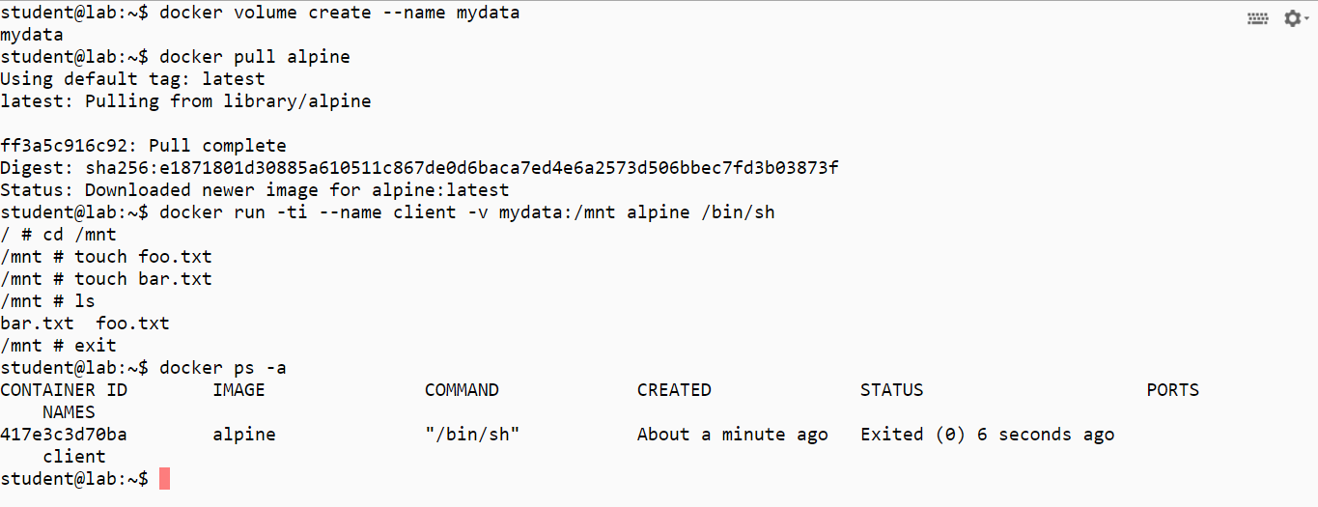

**6.3.3:** Verify the existence of Docker volume

Delete the container and then verify that it is gone.

docker rm client  
docker ps –a

Run a new container and mount the volume mydata to /mnt again.

docker run --rm -ti -v mydata:/mnt alpine /bin/sh

Go to the /mnt directory and observe if the files still exist.

cd /mnt  
ls

Exit the container.

exit

Verify that the volume still exists.

docker volume ls

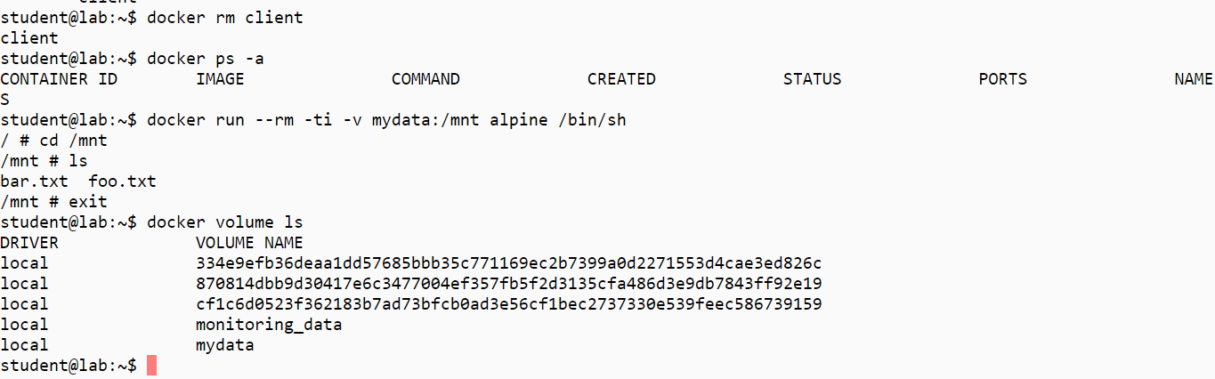

Clean up artifacts. (Please refer to the screenshot.)

docker rm -f $(docker ps -aq) .  
docker rmi $(docker images -q)  
docker volume rm $(docker volume ls -q)

